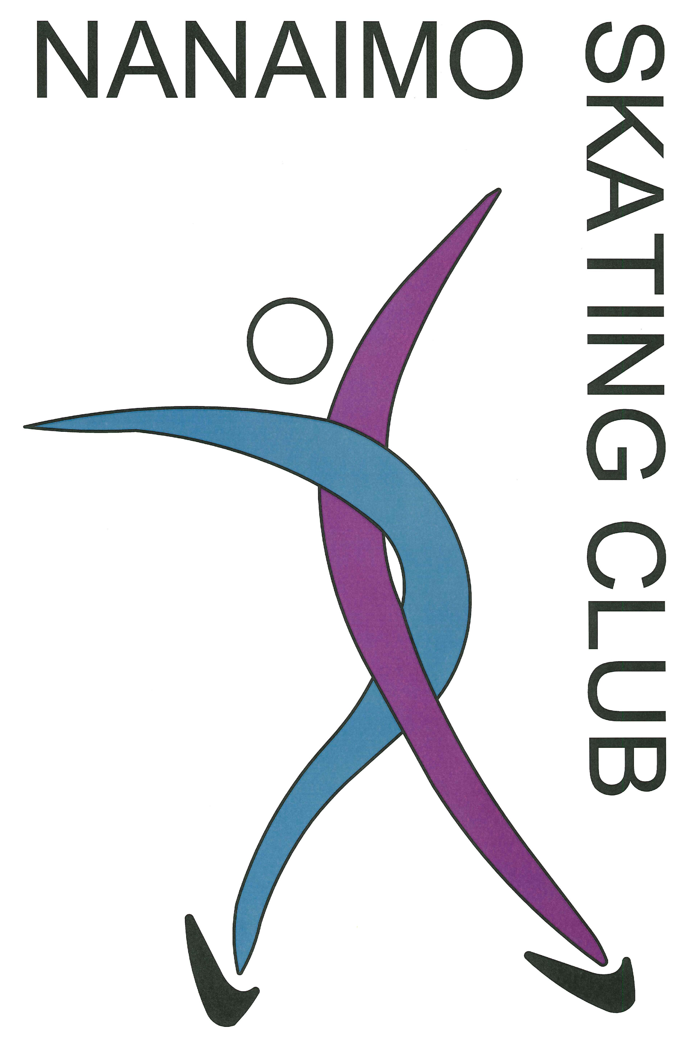

How did you hear about the Nanaimo Skating Club?

Registration Information and Frequently Asked Questions:
- CanPower is coached by certified Skate Canada coach.
- Ice fees must be paid prior to the start of sessions. Skaters who have not paid their fees will be asked to leave the ice.
- All skaters must be members of Skate Canada. Annual membership is paid in September and includes insurance. The fee is non-refundable.
- There are no refunds after three weeks of commencement without a medical certificate and a $20 administrative fee will be incurred.
- All families are expected to participate in the Nanaimo Skating Club fund raising program.
- For other questions, please email nanaimo_skating_club@yahoo.com

Winter 2020/2021

CanPowerSkate

Wednesdays

6:30 – 7:30 am

Block 2: January 6 – March 10, 2021

Cliff McNabb Arena

Beban Park Complex

2300 Bowen Road, Nanaimo

CanPowerSkate Sessions
Registration Form:

Skater Name: ________________________________________

Address: ____________________________________________

City: _________________________ Postal Code: ___________

Email: ______________________________________________

Phone: Home: _________________________

Cell: _________________________

Work: _________________________

Date of Birth: month________/ day______/ year__________

Parent/Guardian Name: ________________________________

Skate Canada #: ________________________________

Waiver:

The undersigned agrees to hold and save harmless the Nanaimo Skating Club, their officers and staff for any claims and injuries sustained during skating sessions including the loss of property. The undersigned agrees to abide by the code of conduct of the Nanaimo Skating Club and the rules of Skate Canada.

Print name: __________________________________________

Date: month_______/ day_____/ year_________

Signature: ___________________________________________

(Parent or guardian if skater is under 19)

Block 2: January 6, 2021 – March 10, 2021
Days | Time |  | Tick day attending
Wednesdays 6:30-7:30 am |  |  | $200

January 6, 13,20,27, Feb 3, 10, 17, 24, March 3, 10

All skaters must wear hockey equipment and CSA approved helmet.
Total Ice Time Fee |  |  |  | $

Other Fees
Skate Canada Registration Fee |  | $50
Nanaimo Skating Club Membership Fee |  | $1
Total Fee |  |  |  | $

Registration and payment is only available online. No skaters will be allowed on the ice without being registered and having their waivers signed. This form is for scheduling and pricing purposes only.
- All ice time fees include a 10% discount via a Community Gaming Grant
Please note: The CanPowerSkate program is exclusive to Skate Canada and is available only to Skate Canada member clubs and sanctioned skating schools. All participants must be registered with Skate Canada. Only Skate Canada member Coaches trained and certified at a CanPowerSkate Coaches Course are qualified to instruct the CanPowerSkate program.

Nanaimo Skating Club is excited to be offering this program for the second time with Nationally accredited Craig Burns as the instructor. Craig has been teaching skating skills for 26 years and is eager to build on last years CanPowerSkate program this year. Craig’s background in figure skating gives him the unique opportunity to pass along skills that have taken him to Junior Worlds, national figure skating championships and beyond. Craig’s determination and drive comes from the desire to see his students improve their power skating abilities on every session.

