

|  |  |  |  |
| --- | --- | --- | --- |
| Days | Time | Tick day(s) attending | |
| **Rising Stars** | | | |
| Mondays, 28 sessions 6:00 – 7:00 pm | | |  |
| Tuesdays, 28 sessions 3:45-4:45 pm | | |  |
| Wednesdays, 28 sessions 6:00-7:00 pm | | |  |
| Thursdays, 28 sessions 3:45-4:45 pm | | |  |
| Enrichment sessions Tuesday Thursday  Enrichment Sessions are coach led ice time focusing on ice dance and skills, etc All lesson time is included in enrichment class only  Enrichment = $150/session for the season  ***Note:*** *Skaters skating 3 or more sessions per week include the Enrichment Session fee*   * Tuesday 4:45-5:30 pm * Thursday 4:45-5:30 pm   **Friday Off Ice Dance class – Harbour City Dance $150**  Fridays 3:30 – 4:30 pm  ***Note:*** *Skaters skating 3 or more sessions per week get this for free* | | |  |
| 1 session a week $400  2 session a week $650  3 session a week $800  4 session a week $900 | | |  |
| **Other Fees** | | | |
| Skate Canada Registration | | $65 |  |
| Ice Show Fee – Mar 11, 2023 | | $75 |  |
| Nanaimo Skating Club Membership Fee | | $1 |  |
| **(10% taken off all session pricing due to gaming grant subsidy)**  **Total** | | |  |

_______________________________________________

Registration Form:

Name _________________________________________

Address ________________________________________

City ________________ Postal Code _________________

email __________________________________________

Phone: home ____________________

cell ____________________

work ____________________

Date of Birth month______/day______/year_______

Parent/Guardian __________________________________

Skate Canada # __________________________________

Coach _________________________________________

Waiver:

The undersigned agrees to hold and save harmless the Nanaimo Skating Club, their officers and staff for any claims and injuries sustained during skating sessions including the loss of property. The undersigned agrees to abide by the code of conduct of the Nanaimo Skating Club and the rules of Skate Canada.

Print name: _____________________________________

Date: month_____/day_____/Year_____

Signature: _______________________________________________

(Parent or guardian if skater is under 19)

**Fees for Rising Stars and StarSkate Sessions do not include professional coaching. Athletes will be billed separately by coaching staff**

**Fees for CanSkate include professional coaching**

**There is no ice Oct 9, Feb 190,**

**Mar 11-14**

**Holiday make up classes are available on another day.**

Winter 2023/2024

Rising Stars

28 weeks

**September 18, 2023– April 18 2024**

Cliff McNabb Arena

Beban Park



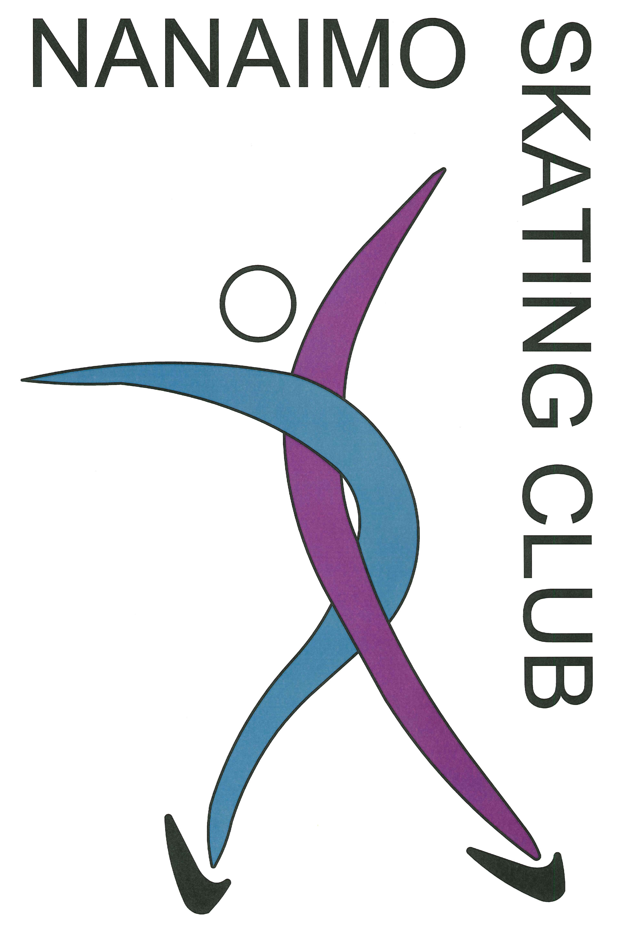

**Registration and payment are only available online. No skaters will be allowed on the ice without being registered. This form is for scheduling and pricing purposes only.**

|  |  |  |  |
| --- | --- | --- | --- |
| **2022/2023 Season Schedule** | | | |
| **Monday** | **Tuesday** | **Wednesday** | **Thursday** |
| 3:45 – 5:00  StarSkate | 3:45 – 4:45  Rising Stars | 3:45 – 5:00  StarSkate | 3:45 – 4:45  Rising Stars |
| 5:00 – 5:15  Ice Resurfacing | 4:45 – 5:30  Enrichment Session  *(available for Rising Stars and StarSkate only)* | 5:00 – 5:15  Ice Resurfacing | 4:45 – 5:30  Enrichment Session  *(available for Rising Stars and StarSkate only)* |
| 5:15 – 6:00  **CanSkate/**  **PrepowerSkate** | 5:30 – 5:45  Rink Flood | 5:15 – 6:00  **CanSkate/**  **PrepowerSkate** | 5:30 – 5:45  Rink Flood |
| 6:00 – 7:00  Rising Stars | 5:45 – 6:45  StarSkate | 6:00 – 7:00  Rising Stars | 5:45 – 6:45  StarSkate |



# Registration Information and FAQ:

# For other questions please email nanaimo_skating_club@yahoo.com

# Ice fees do not include professional coaching. To arrange coaching, please contact our club coach.

1. Ice fees must be paid prior to the start of sessions. Skaters who have not paid their ice fees will be asked to leave the ice.

# Buy ons are available: $20/hr

1. There are no refunds after October 1st without a medical certificate. You will be charged a $20 admin fee.

All Skaters must be members of Skate Canada. Annual membership is paid in September and includes insurance. For skaters this fee is $50, non skaters $1. This fee is nonrefundable.

Registration and payment are only available online. No skaters will be allowed on the ice without being registered. This form is for scheduling and pricing purposes only.

1. .

* Scheduling for individual sessions will be at the discretion of the coaching staff
* StarSkate sessions are open to all skaters at the discretion of the club/coaching staff