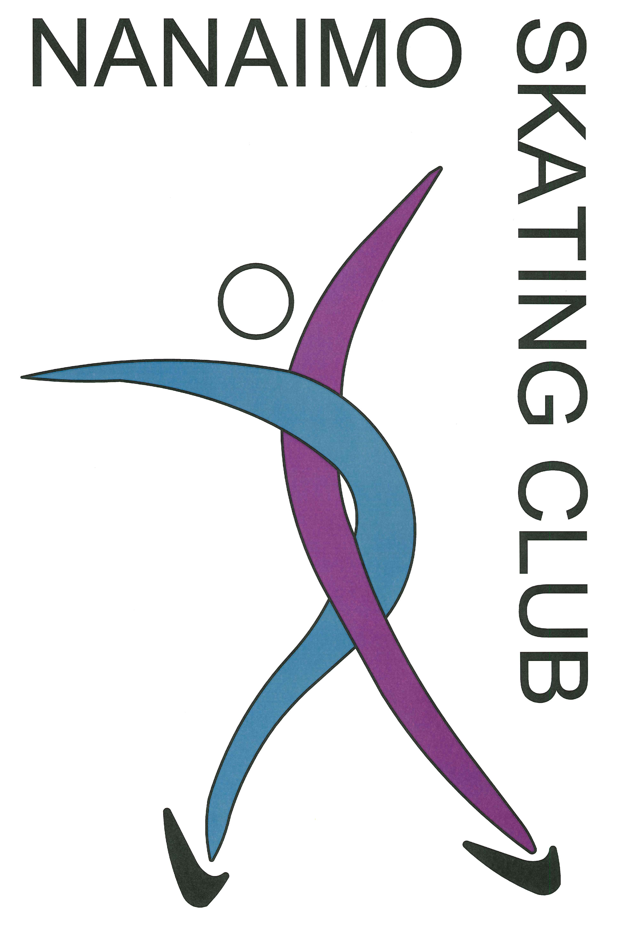

Winter 2023/2024

StarSkate

28 weeks

September 18, 2022 to

April 18, 2023

Cliff McNabb Arena

Beban Park Complex

2300 Bowen Road, Nanaimo

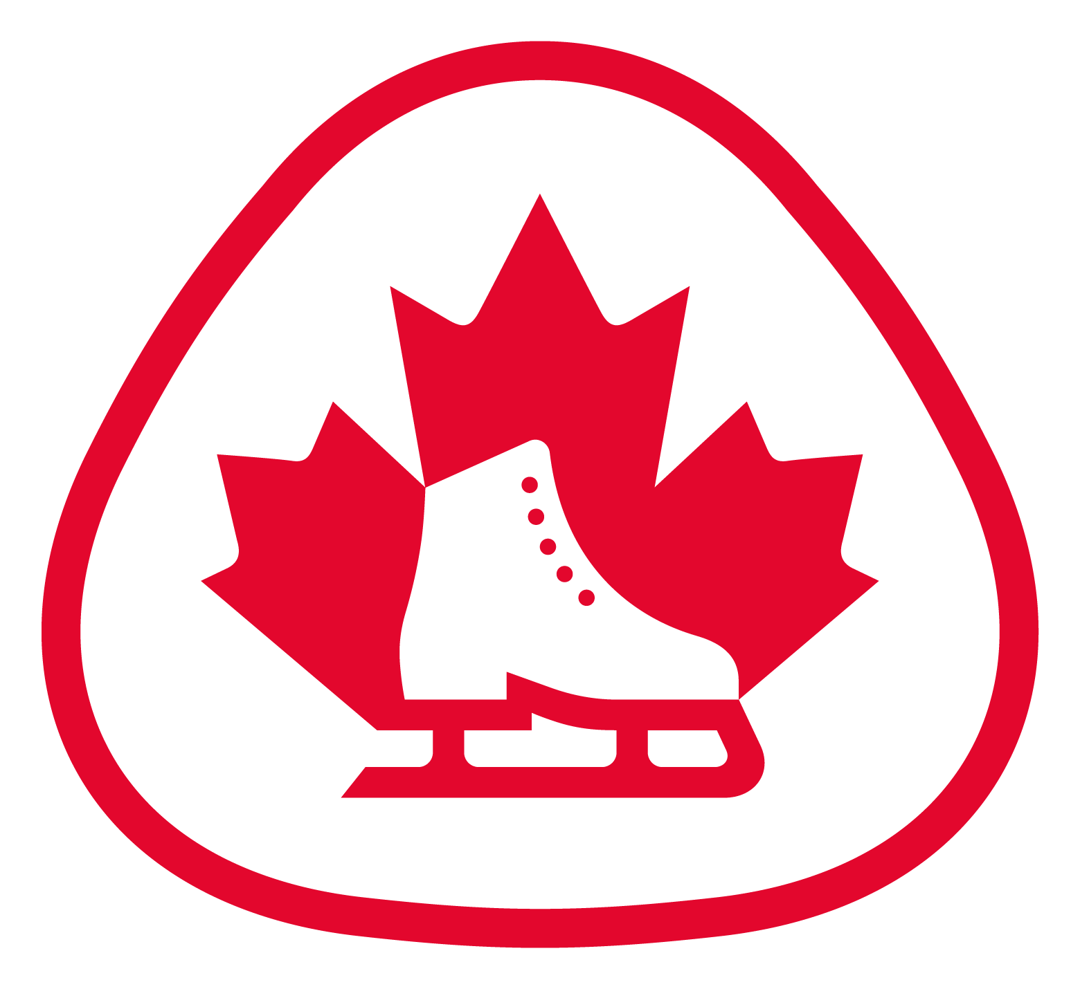

Date Notice:
- There is no ice Oct 9, Feb 19,
- Mar 11-14
- Holiday make up classes are available on another day.

StarSkate Skating Sessions
Days | Time | Tick day(s) attending

Mondays (28 sessions) 3:45 – 5:00 pm

Tuesdays (28 sessions) 5:45 – 6:45 pm

Wednesdays (28 sessions) 3:30 – 4:45 pm

Thursdays (28 sessions) 5:45 – 6:45 pm

Enrichment Sessions are coach led ice time focusing on ice dance and skills, etc All lesson time is included in enrichment class only

Enrichment = $150/session for the season

Note: Skaters skating 3 or more sessions per week include the Enrichment Session fee

- Tuesday 4:45-5:30 pm
- Thursday 4:45-5:30 pm

Friday Off ice Dance class – Harbour City Dance $150

Fridays 3:30 – 4:30 pm

Note: Skaters skating 3 or more sessions per week get this for free

Ice Time Fees

1 session/week = $450 for the season

2 sessions/week = $700 for the season

3 sessions/week = $850 for the season

4 sessions/week = $1000 for the season
Total Ice Time Fee |  |  | $

Other Fees
Skate Canada Registration Fee |  | $65
Ice Show Fee – Mar 11, 2023 |  | $75
Nanaimo Skating Club Membership Fee |  | $1
Total Fee |  |  | $

_______________________________________________

FEES:
- All programs are offered at a subsidized rate due to Gaming grant.
- Professional coaching fees for StarSkate skaters are not included in the registration or ice-fee payment. Skaters will be billed separately by their coach(es) with payment/cheques made directly to the coach.

Registration Form:

Skater Name: ___________________________________

Address: _______________________________________

City: ____________________ Postal Code: ___________

Email: _________________________________________

Phone: Home: ____________________

Cell: ____________________

Work: ____________________

Date of Birth: month______/ day______/ year________

Parent/Guardian Name: ___________________________

Skate Canada #: ________________________________

Waiver:

The undersigned agrees to hold and save harmless the Nanaimo Skating Club, their officers and staff for any claims and injuries sustained during skating sessions including the loss of property. The undersigned agrees to abide by the code of conduct of the Nanaimo Skating Club and the rules of Skate Canada.

Print name: _____________________________________

Date: month_____/ day_____/ year_______

Signature: ______________________________________

(Parent or guardian if skater is under 19)

Registration and payment are only available online. No skaters will be allowed on the ice without being registered. This form is for scheduling and pricing purposes only.

Registration Information and Frequently Asked Questions:

- Ice fees do not include professional coaching. To arrange coaching, please contact the Head Coach.
- Ice fees must be paid prior to the start of sessions. Skaters who have not paid their fees will be asked to leave the ice.
- Additional ice time ‘buy ons’ are available at $20/hour
- All skaters must be members of Skate Canada. Annual membership is paid in September and includes insurance. The fee is non-refundable.
- Refunds after October 1st require a medical certificate and incur a $20 administrative fee.
- Skating competitions are held at various times throughout the season. Information about competitions will be communicated to skaters/families by email.
- Competition registration is done online through Skate Canada BC/Yukon at http://www.skatinginbc.com/ and may require input from the Head Coach.
- For other questions, please email nanaimo_skating_club@yahoo.com

2023/202 Season Schedule
Monday | Tuesday | Wednesday | Thursday
3:45 – 5:00  StarSkate | 3:45 – 4:45  Rising Stars | 3:45 – 5:00  StarSkate | 3:45 – 4:45  Rising Stars
5:00 – 5:15  Ice Resurfacing | 4:45 – 5:30  Enrichment Session  (available for Rising Stars and StarSkate only) | 5:00 – 5:15  Ice Resurfacing | 4:45 – 5:30  Enrichment Session  (available for Rising Stars and StarSkate only)
5:15 – 6:00  CanSkate/  PrepowerSkate | 5:30 – 5:45  Rink Flood | 5:15 – 6:00  CanSkate/  PrepowerSkate | 5:30 – 5:45  Rink Flood
6:00 – 7:00  Rising Stars | 5:45 – 6:45  StarSkate | 6:00 – 7:00  Rising Stars | 5:45 – 6:45  StarSkate

